

PlanetAir® HD50 Aerator
Owners Manual
2003 thru 2009 Models

PlanetAir Turf Products, LLC
1065 24th Avenue SW
Owatonna, MN 55060

Phone: 877-800-8845
Fax: 507-455-2788

Email: info@planetair.biz

Website: www.planetair.biz

PlanetAir® is a registered trademark of PlanetAir Turf Products, LLC

Table of Contents
Limited Warranty Conditions 4
Specifications 5
How to Obtain Parts and Service 6
General Safety Practices 7
General Safety Practice 8
Training 8
Clothing 8
General Safety Practice 9
The Operator 9
The Machine 9
General Safety Practice 10
Pre-Operation 11
Pre-Operation Check List 11
Work Site Preparation 11
The Utility Vehicle and PlanetAir Aerator 12
Choosing a Utility Vehicle or Tractor 13
Hitch Requirements to Tow 13
Tractor Requirements – 3 Point Hitch 13
Hydraulic Requirements - 2-way hydraulics 13
Choosing a Utility Vehicle or Tractor (continued) 14
Hydraulic Requirements - 2-way hydraulics 14
Hitching PlanetAir to your Utility Vehicle 15
Attaching PlanetAir to Tractor 3 Point 16
Attaching PlanetAir to your Tractor 16
3 Point Hitch 16
Lift Arm Towing Hitch 16
Sizing PTO Shaft to the Utility Vehicle or Tractor 17
Hydraulic Hookup and Testing 18
Wheel Arm Pivot Replacement and Service 19
Engine Control Shaft Function and Adjustment 20
Knife Selection Guide – Aerator Setup 22
Knife Installation 24
Spring Settings (relief system) 25
Roller Up / Roller Down Setting 26
Rotor Height Adjustment 27
Timing Arm, Timing Spring, Timing Rubber Bumper Replacement 28
Timing Chain Replacement 29
Timing Chain Fixtures Required 29
Timing Chain Fixtures Installation 30
Tine Shaft Bearing Replacement 31
Rotor Removal 32
For replacement of Rotor Double Sprocket, Rotor Pulley 32
Drive Belt Replacement 33
Reduction Belt 33
Wheel Jack Service and Lubrication 34
Lubrication 35
Troubleshooting 36

PARTS BOOK …………………………………………………………………………………………. 38

Limited Warranty Conditions

PlanetAir Product is delivered to the customer accompanied by a limited warranty
against defects in the materials and workmanship.

This warranty applies for a period of 12 months as of the date of purchase. Three months for Contract Industry.

PlanetAir warranty is viewed by the use in: “General Conditions of Maintained Turf”.

All incidental and consequential damages, including pickup and delivery of the unit, communication, mileage charges and or rental of replacement unit during repair, are not covered under this warranty, nor is any loss of income and/or any other loss resulting from the failure of this product due to a warranty defect.

Warranty Registration and Inspection Report must be filled out and returned within 30 days of purchase to:

PlanetAir Turf Products, LLC
1065 24th Ave SW
PO Box 625
Owatonna, MN 55060
Ph: 507-446-8399
Fax: 507-455-2788
Email: info@planetair.biz
Web: www.planetair.biz

The Following items are not covered under PlanetAir warranty, and are warranted by their respective manufacturer.
- Engine and engine parts.
- Gear boxes and PTO drive lines.
- Batteries
- Wheels and tires.
- Chains, bearings, belts, sprockets, and pulleys.
- Hydraulic Cylinders
A copy of the warranty for the above items is furnished if necessary with the PlanetAir product.

Specifications

PlanetAir Specifications:

Aerating Depth | Up to 3 ½ Inches Deep
Aerating Width | 48 Inches Wide
Aerating Hole Pattern | 2” x 1” thru 2” x 5”  varied by ground speed
Aerating Speed | 2 to 7 mph
Aerating Rate | 1,000,000 holes per Hour
Transport Speed | NOT to exceed 10 mph
Power Supply | 540 PTO, 20 horsepower
Dimension:

Height | 30 Inches
Width | 64 Inches
Length | 32 Inches
Weight | 1300 Pounds
Shipping Weight | 1400 Pounds
Knife Options:

Shatter Knife | 1/8″, 1/4″ and 3/8″
Coring Knife | 1/2″ and 3/4″

How to Obtain Parts and Service

To order parts or to arrange repair service contact your authorized PlanetAir dealer. For a list of authorized dealers in your area or for addition information regarding the PlanetAir Aerator check the PlanetAir website at www.planetair.biz or direct inquires to:

PlanetAir Turf Products, LLC
1065 24th Ave SW
PO Box 625
Owatonna, MN 55060
Ph: 507-446-8399
Fax: 507-455-2788
Email: info@planetair.biz
Web: www.planetair.biz

To ensure safety and proper operation, always purchase genuine PlanetAir Aerator replacement parts from an authorized PlanetAir dealer. Replacement parts from other sources may damage the aerator and/or create a safety hazard. Always refer repairs to properly trained service personnel. DO NOT ALTER the PlanetAir Aerator in any manner. Unauthorized alterations may affect its operation, performance and may result in injury or death to operator or other individuals in the working area.

Product Records
IMPORTANT: Record the information from your PlanetAir Aerator. It may become necessary to furnish your model, product and serial number when ordering parts.

Model Name PlanetAir HD50

Serial Number ________________________________________________

Date Purchased _________________________________________________

Dealer Name __________________________________________________
General Safety Practices

Recognizing Safety Warnings used in the Manual:

LOOK FOR THE SAFETY HAZARD WARNING SYMBOL


This symbol is used to alert the operator of safety hazards.

DANGER
“DANGER” identifies immediate hazards which will result in serious injury or death.

WARNING
“WARNING” identifies potential hazards which could result in serious injury or death.

CAUTION
“CAUTION” identifies hazardous situations which may result in minor to moderate injury and or could result in damage or destruction of equipment

General Safety Practice

Safety on the job should always be a top priority. Training and experience are important factors in the safe operation of equipment. Please consider the following information and realize that safe operation is a matter of using common sense as it relates to the machine, its maintenance, the operator, the training and the operating conditions. These are general safety instructions that apply to most turf maintenance equipment.

Training:

- Always read the manual before operating a machine for the first time.
- Always read the warning decals before operating a machine for the first time.
- Always check the location and use of each control before operating a machine for the first time
- Practice operating the machine in a safe area with the controls. If you have a question, ask your supervisor to call the factory.

Clothing:

- Clothes should be snug fit. Loose fitting clothing is hazardous because it may get caught in the mechanism during service operations.
- Remove jewelry before operation. Again, jewelry may get caught in the mechanism.
- Wear shoes that will protect your feet. In most cases, sneakers do not protect and do not provide the protection of leather shoes or boots. Steel toed safety shoes should be considered for many situations.
- Hard Hat – the use of a hard hat should be considered when using equipment on a golf course. The danger of being hit by a golf ball should be a major concern as well as protection while operating under trees.
- Eye Protection – Safety glasses and/or face shields should be considered when operating, as well as working in close proximity to high speed rotary equipment.
- Hearing – if the noise in the equipment is tool loud, consider the use of ear protection.
- Do not use stereo headsets during operation. This is a distraction that may lead to an accident. Headsets also make it difficult to hear other people and equipment while operating the aerator.
- Respirators – when operating in dusty, windy conditions wear a respirator. This is also an important consideration if operating equipment while spraying chemicals and fertilizers.
- Gloves – use gloves when handling sharp or hazardous objects.

General Safety Practice

The Operator:

- Care should always be taken when mounting and dismounting a riding machine. Prevent injuries and falls by making sure the operator does not slip. Unless it is an emergency, do not jump off a machine. Injury may result when an operator’s foot slips trying to jump from a machine.
- Do not operate any equipment at unsafe speeds. Speeds should be reduced when turning or operating on slopes. The operator must use common sense to determine a safe speed based on the equipment, the load, the slope, the surface, and other conditions that may effect safe operation.
- The operator must be aware of the conditions around the area. Be careful to observe other people and machines
- Beware of slipper conditions. Wet turf can be encountered on slopes, when turning or stopping, or at high speeds.
- Keep hands and feet away from cutting devices and drive components. Shut off engine and remove the keys or ignition wire when servicing cutting devices or drive components.
- If required to lift, an operator should ask for help if the object is too heavy. The operator should lift with his or hear legs instead of back. Care should be taken to avoid twisting the back while lifting a heavy load.
- Never allow children to operate the machine.

The Machine:

- Do not modify the machine in any manner. Always check the machine to make sure it is in good working order.
- Do not place hands or feet near moving or rotating parts. Inspect to insure that all guards are in place. Do not operate machine without guards in place.
- Check to assure that all controls are in good operating condition. Make sure the breaks are operating properly.
- Check the tire pressure
- Do not overload the machinery. The components are designed for certain weights and capacities. Overloading the machine will cause unsafe conditions.
- Utility vehicles must have adequate hitches and brakes to control any towed machine. Check the weight and capacity of the machine that will be towed by that utility vehicle.
- Check the condition of the hydraulic hoses. Leaks and worn hoses should be fixed or replaced before the machine is put into service. Do not use your fingers or hands to check for hydraulic leaks. High pressure can puncture the skin and force oil into the body. This can cause severe injury or death.

General Safety Practice
- Shut off the engine before servicing the machine. Check machines on a level area. Machines on a slope may roll when the engine is off.
- Refer unfamiliar repairs and adjustments to mechanics that have been trained to do them properly.
- Replace decals that have become damaged or illegible.

NOTE:
This list includes many, but not all, general safety instructions as they relate to turf equipment.
Common sense must always be used to determine the safest way to operate a machine under specific conditions.

Pre-Operation

Pre-Operation Check List
Wear the appropriate safety gear. Safety glasses and safety shoes are recommended when operating the PlanetAir.

- Grease – All lubrication fittings daily. See lubrication instructions
- Check – All guards and covers are in place
- Check – Engine filters and lubricants.
- Check – All fasteners. Retighten any loose nuts and screws to ensure safe operation.
- Check – Tires for any possible wear, damage and proper inflation. Tires should be inflated to 22 psi on the PlanetAir.
- Chains and belts for wear and proper tension
- The work site for above and below ground obstructions and or dangerous areas
- Shatter or Coring Knife – make sure they are in good working condition, in the proper position and securely fastened.

Work Site Preparation
Under certain conditions, the PlanetAir knife can reach a depth of 4 ½ inches. Damage will occur to any buried object that knife may come in contact with. Plan your path and know the location of any below ground as well as above ground objects that could be damaged by the aerating process.

- Locate and mark all shallow buried electric service, cable TV, telephone, outdoor lighting and any other buried cable that may be damage d by the aerating process.
- Locate and mark all irrigation heads, above and below ground irrigation control boxes and any shallow buried irrigation lines that may be damaged by the aerating process.
- Locate and mark all shallow buried natural gas, propane gas, or other gas or fuel lines that may be damaged by the aerating process
- Locate and mark all shallow buried root drain pipes, drain pipes, drain tiling, drain catch basins or any other buried drainage items that maybe be damaged by the aerating process

WARNING

Before Operating this Machine,
Read and Understand this Entire Manual

The Utility Vehicle and PlanetAir Aerator

Be trained in the operation of the utility vehicle and knowledgeable in its safe operation. Be aware of the extra weight placed on the utility vehicle when combined with the PlanetAir aerator The extra weight will affect the handling, balance and breaking performance of the utility vehicle. Operate the utility vehicle in a safe manner. Know the operating limits of the utility vehicle in relation to the weight, performance, and operating characteristics of the PlanetAir.

NO EXTRA WEIGHT TO BE ADDED
TO THE PLANETAIR AERATOR

The forward speed of the utility vehicle regulates the spacing between rows of aerating holes.

Required Power to the PlanetAir is a 540 rpm PTO, minimum 16 horsepower.

Low range gears can be used at a minimum of 2 mph. Maximum forward ground speed is 7 mph.

Choosing a Utility Vehicle or Tractor

Hitch Requirements to Tow
- 2 way hydraulics
- 2″ ball mounted directly below PTO.
- Top of 2” Ball should be approximately 9” from the ground to allow the Hitch Pole to run downhill 2” to the PlanetAir Aerator.

Tractor Requirements – 3 Point Hitch
- 3 Point Hitch capable of operating 1200# aerator
- Tractor must be sized to lift and operate 1200# aerator

Hydraulic Requirements - 2-way hydraulics

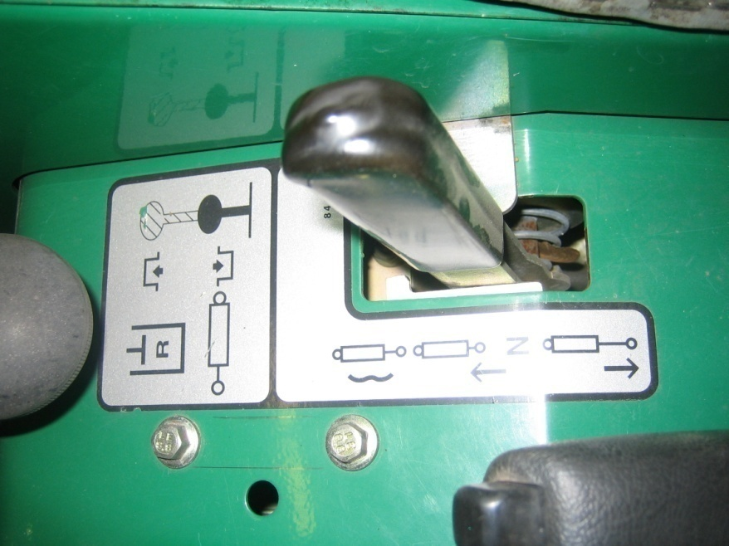

Choosing a Utility Vehicle or Tractor (continued)

Hydraulic Requirements - 2-way hydraulics
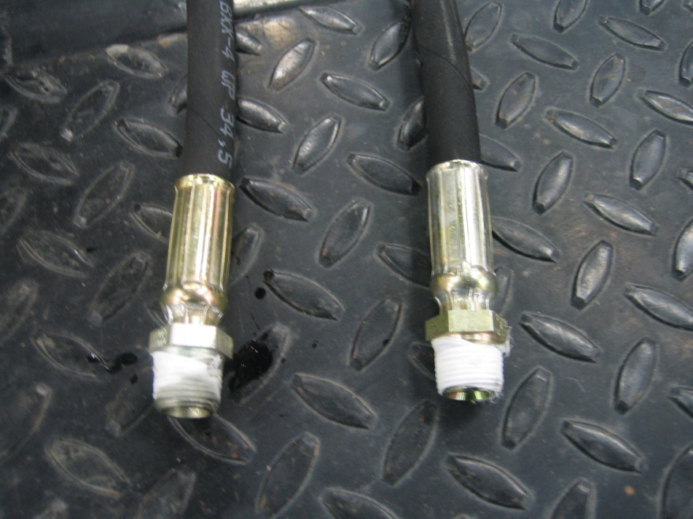

- Hydraulic hoses come equipped with 3/8″ male pipe thread.

- Hydraulic quick couplers are not provided. They need to mate with your Utility Vehicle.

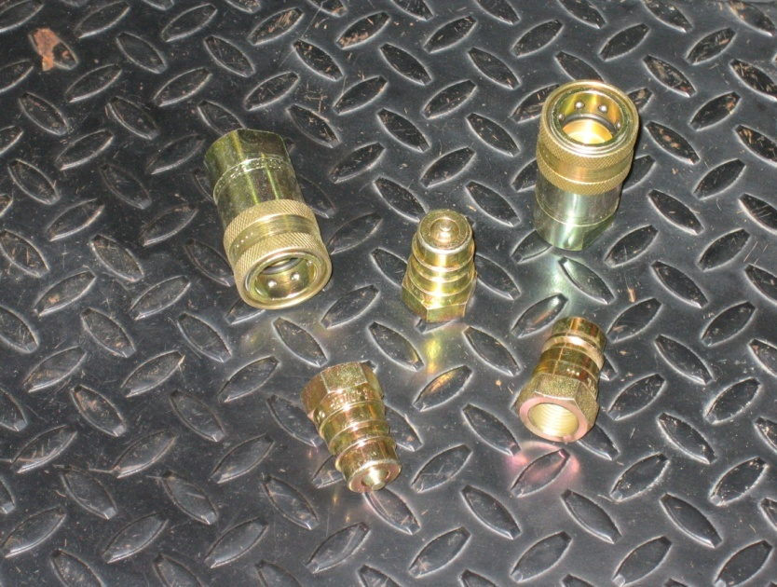

Inspect Utility Vehicle manual for proper operation and hookup of two-way hydraulics

Hitching PlanetAir to your Utility Vehicle

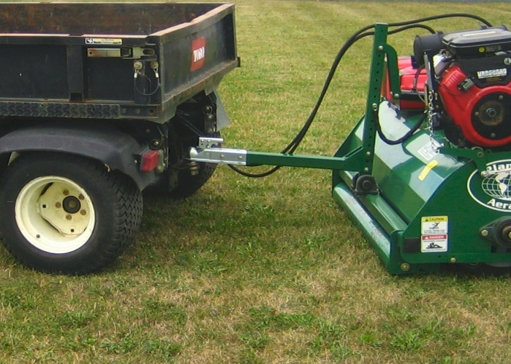
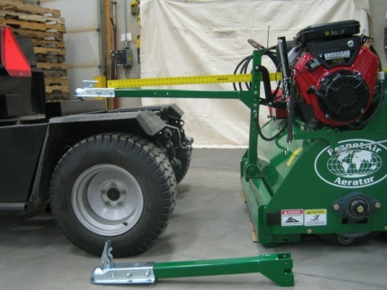

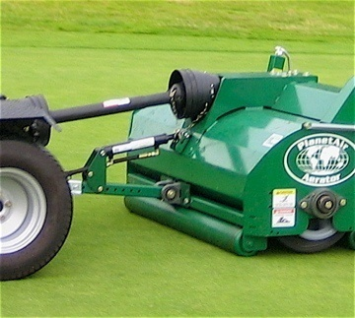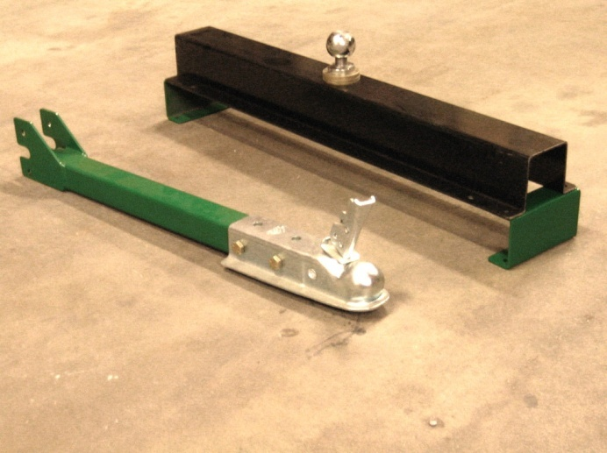

1. With PlanetAir rollers resting on a level surface the Hitch Pole MUST BE INSTALLED TO RUN DOWNHILL 2”-3” to the PlanetAir Aerator
2. For lowest setting mount pole with bracket up.
3. Raise ball mounting position on tow vehicle.
4. Do not move position of control chain.
5. Hitch pole should be cut off for rear hitch towing.
6. This setup will give more clearance on the rear roller in transport.
7. This setup is needed to prevent lift cylinder damage due to the hitch binding.
8. Note that the hitch ball neck is reduced to provide more hitch angle to increase lift cylinder protection.

Attaching PlanetAir to Tractor 3 Point
Check the machine for damaged and/or missing parts. Do not operate or attempt to operate the aerator with missing or damaged parts.

Attaching PlanetAir to your Tractor

PlanetAir is attached to the tractor by 3 connecting points. Attach the aerator to the tractor and secure with the 3 connecting points. On the tractor you need a floating lower point. Check the operation of the 3 point connection and ensure that the aerator can be safely raised and lowered. Two connections are quick release pins on the PlanetAir. The third connection has a chain which allows for variables in terrain conditions and must be adjusted properly. This is the top connection and should be adjusted so that the top connecting link of the PlanetAir is able to move forward and backward during operation and not bind against the connecting points. The top connecting point should be adjusted with the tractor and PlanetAir resting level on the ground. The chain should have slight tension in it for proper operation. Never apply down pressure to the PlanetAir from the third point.

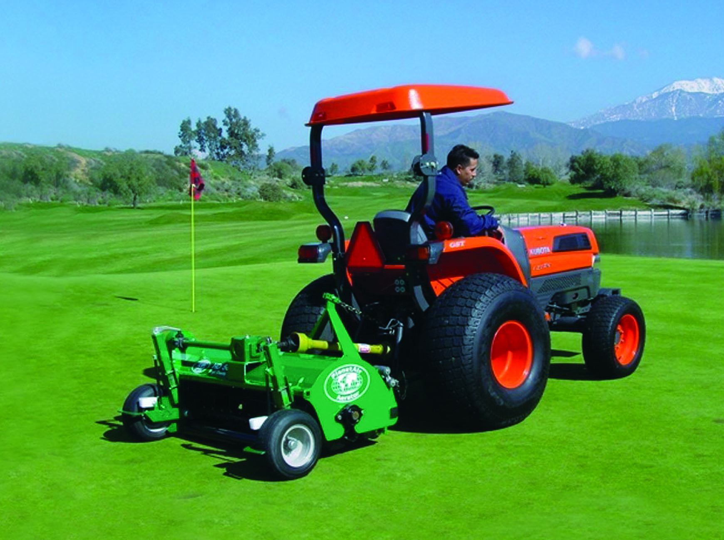 3 Point Hitch

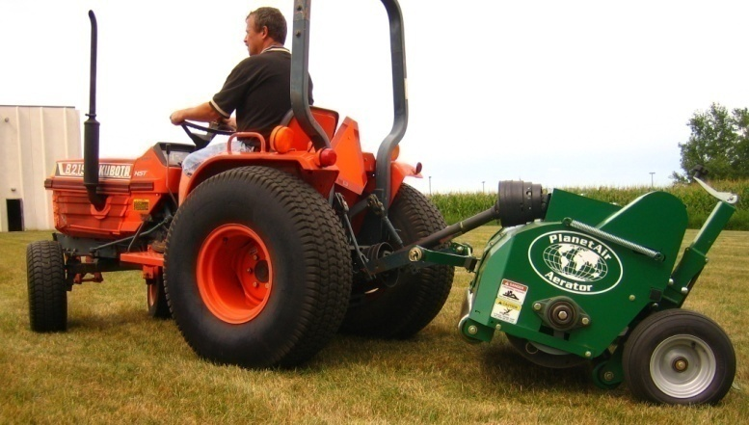 Lift Arm Towing Hitch

Sizing PTO Shaft to the Utility Vehicle or Tractor

To accommodate the differences in locations of the Utility Vehicle or Tractor PTO output shafts and to accommodate the different types and sizes of 3 point hitches, the PlanetAir is supplied with a long PTO shaft. The length of the PTO drive shaft may require shortening to properly fit the tractor used.

Before shortening the PTO shaft, check the following:

- Measure the length required with the PlanetAir fully raised.
- Measure the length required with the PlanetAir straight out from the tractor PTO takeoff.
- Measure the length required with the PlanetAir lowered to the lowest possible point.
  - Allow length for PTO take-off connection.
  - Allow length for PlanetAir spline connection
  - Recheck all measurements before cutting.

- The PTO shaft must not bind while raising or lowering the PlanetAir with the 3 point connection. The PTO shaft must stay properly attached to the power take-off and the PlanetAir spline connection. Ensure that the guard still fits the shaft. The Guard must be fully functional and cover the entire PTO shaft.

Hydraulic Hookup and Testing
The best choice is to unplug dump box lift cylinder and use those same ports and control handle. Note the hydraulic couplers you disconnect and source the same coupler ends for installation on PlanetAir hoses. Consult Utility Vehicle or Tractor manual for proper two-way cylinder hookup.

- Plug in hoses
- Pull hydraulic handle to raise the Aerator. If the Aerator doesn’t rise reverse the hose hookups.
- Push hydraulic handle down and hold until cylinder retracts completely.

Trouble Shooting: Cylinder does not retract completely.
- Control handle operated in float position instead of down position
- Hose not connected completely in coupler
- Wrong port chosen

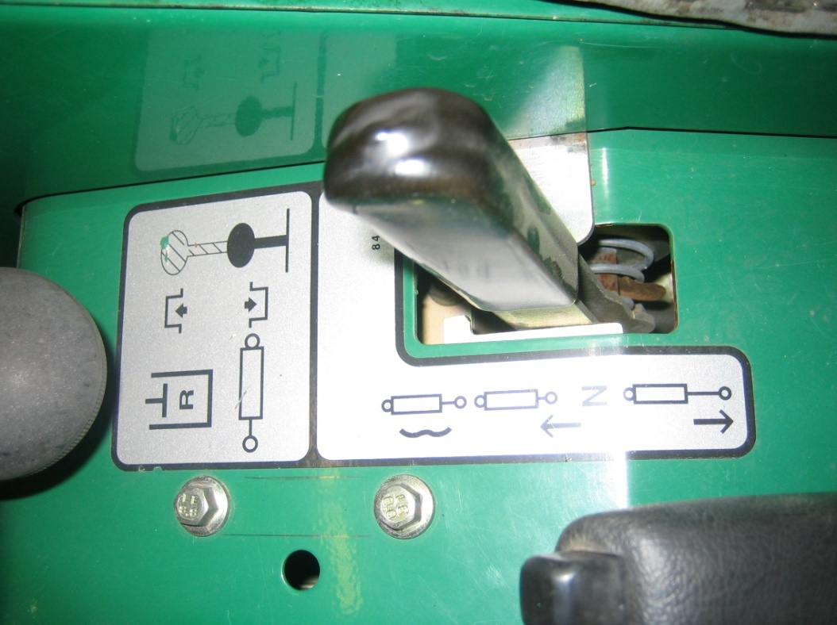

Wheel Arm Pivot Replacement and Service
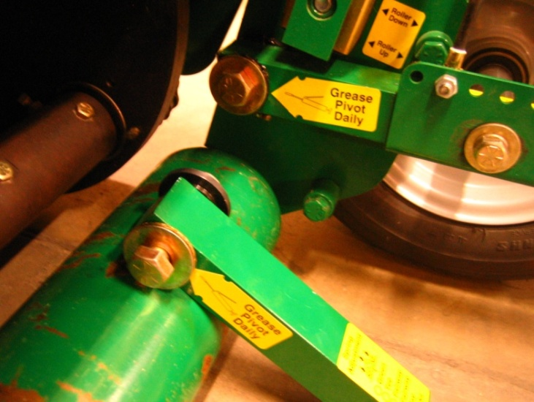
- Place wood blocks under rear roller
- Extend jacks completely to relieve spring pressure
- Remove and replace old pivot
- Loc-tite bolt and impact until tight
- Grease pivot frequently
- Place block under rear roller.
- Work arm up and down when greasing to surround pivot with grease.
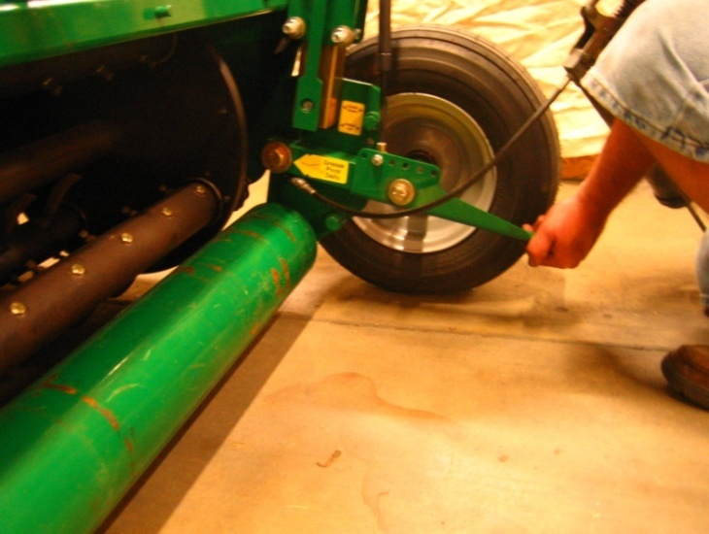
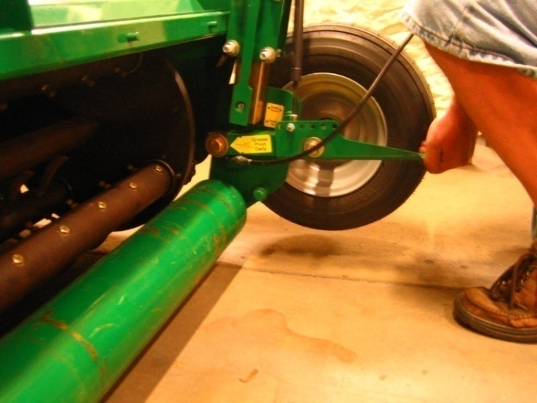

Engine Control Shaft Function and Adjustment

PlanetAir is equipped with mechanical controls which operate the clutch and throttle.

When the Aerator is raised the Hitch Pull Chain rotates the Control Shaft pushing and relieving the belt tension and pulling the throttle off on the engine.

When the Aerator is lowered the chain is relieved and the central spring provides tension through the control shafts on the belts and relieves tension on the throttle pull-off chain allowing the throttle spring to accelerate the engine.

Hint: Throttle cable must be kept lubricated for engine to accelerate.

Inspecting Proper Adjustment of the Pull-off Chain

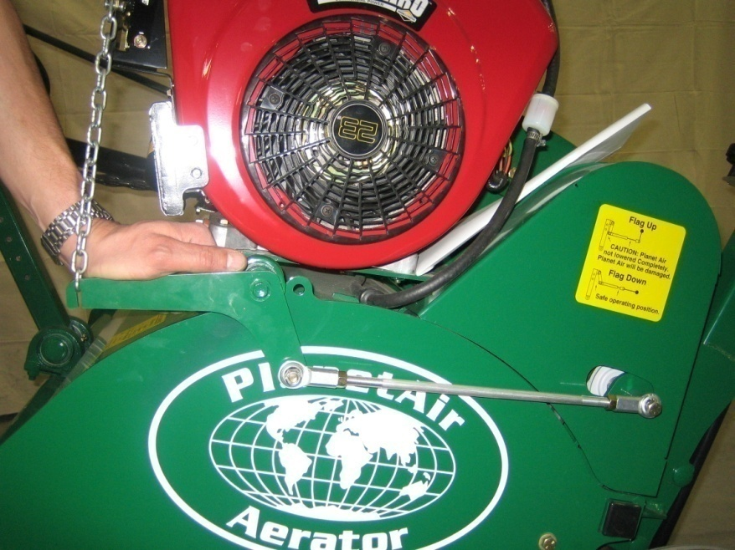

- Aerator is fully raised
- With the palm of your hand push down on the left Control Arm. It should be tight.
- Two methods exist to adjust this braking action. One is to extend the Control Rod. The second method is to remove the Pull-off chain, twist it a number of times and reinstall it. This shortens the chain in small increments.

Hint: You are pushing against the Belt Tensioner Pulley which should be tight against a rubber braking Bumper located inside the Belt Guard. This Bumper brakes the Belt Tensioner Pulley providing drag on the Drive Belts.

Inspecting Proper Adjustment of the Pull-off Chain - continued

Hint: Holding the Control Arm down with the Aerator in the upper most position gauges how many turns you need on the chain.
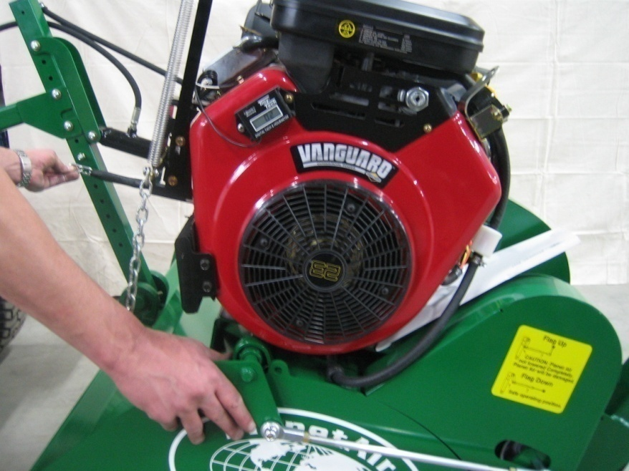

Knife Selection Guide – Aerator Setup

The PlanetAir Knife is specifically designed to interact with our patented planetary motion. They are different from any other knife. PlanetAir provides for two category of knife.
- Shatter Knife technology provides 3 Knife thicknesses – 1/8″, 1/4″ and 3/8″
- Coring Knife technology provides 2 plug sizes – 1/2″ and 3/4″ ID. The coring knife is primarily for detaching with minimal cleanup.

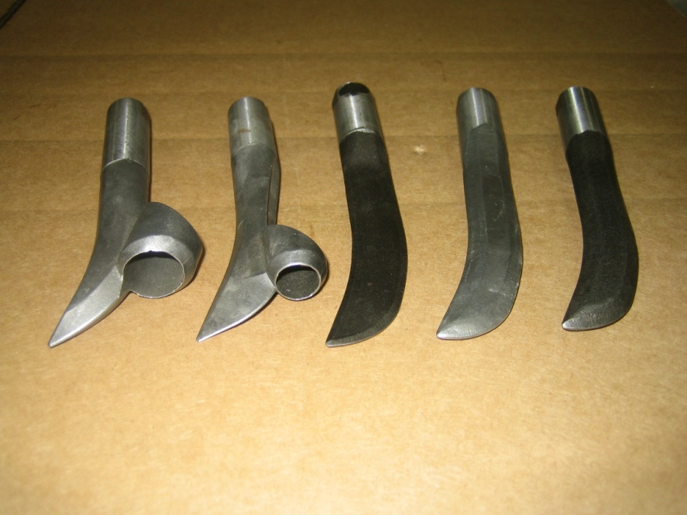
All Knifes are manufactured from high grade, heat treated tool steel.
HINT: The key to using PlanetAir technology in fairways is to set a depth, head pressure and ground speed that allow the Aerator to operate effortlessly. Multiple passes and frequency will get the job done.

Knife | Benefits | Aerator Setup
Part# 560.317  1/8″ Shatter Knife | Designed for putting green surfaces. No cleanup and minimum disruption to ball roll. Preserves fast, smooth, firm surface. Generally increases ball roll by 1 foot. Used on greens as often as weekly.  NEGATIVE: This Knife will not survive contact with rocks. | - Roller Down Position.  - Roller Down Chart Height is safely set at ¾” to 1 ¾”.  - Ground Speed approximately 3 mph for 2x2 spacing.  - Head Pressure setting – if desired move Spring forward for less tire pressure and more roller pressure on greens.

Knife | Benefits | Aerator Setup
Part# 560.319  1/4″ Shatter Knife | Similar to 1/8″ knife.  Broader slit. More disruption to ball roll. Slightly softer surface conditions.  More resistant than 1/8″ to rock hits. Longer wear capability. | - Roller Down Position.  - Roller Down Chart Height is safely set at 3/4″ to 1 3/4″  - Ground Speed approximately 3 mph for 2x2 spacing.  - Head Pressure setting – if desired move Spring forward for less tire pressure and more roller pressure on greens.  Hint: if 1/4″ knife is used in hard or rocky conditions follow recommendations for Aerator Setup 3/8″ Shatter Knife.
Part# 560.320  3/8″ Shatter Knife | Our toughest Shatter Knife. Best survivor in harsh conditions | Recommendations for hard and rocky conditions  - Use short, worn, 3/8″ knife. Shorter knife lessens stress and impact on Aerator components.  - Set Head Pressure as low as possible. This reduces impact when rocks are hit  - Set to Roller Up position. Wheel will absorb impact and protect Aerator.  - Set Height to avoid hitting rocks  - Operate Aerator at near 4 mph (very fast walk to jogging speed )
Part# 560.321  1/2″ Coring Knife | 1/2″ ID  Used for greens and tee mix areas.  NEGATIVE: ½″ coring will not survive rock hits or hard soil conditions. | - Stops in Roller Up position to avoid build up of cores on rear roller  - Roller Up Chart Height is safely set at 1/2″ to 3/4″  - Head Pressure to highest setting (move springs all the way forward)
Part# 560.322  3/4″ Coring Knife | 3/4″ ID  Our toughest Coring Knife. Used for all areas  Our Coring Technology is primarily for detaching with minimal cleanup. | - Stops in Roller Up position to avoid build up of cores on rear roller  - Roller Up Chart Height is safely set at 1/2″ to 3/4″  - Head Pressure to highest setting (move springs all the way forward)  Hint #1: In hard conditions when the Aerator is floating, to increase penetration remove every other Coring Knife and replace with a worn-out 3/8″ Shatter Knife.  Hint #2: As always drive near 4 mph in hard conditions and go over hard areas multiple times.

Knife Installation
Place Aerator in the Maintenance position
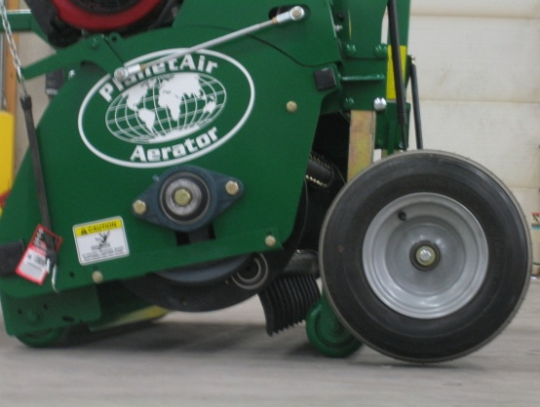
- Lower Aerator. Warning Flag Down.
- Check that Wheel Stop is in the Roller Down Position
- Loosen 8 Jack Clamp bolts
- Raise Rotor until tires leave the floor.
- Pull off the Drive Belt Tensioner with a 12” rubber strap.

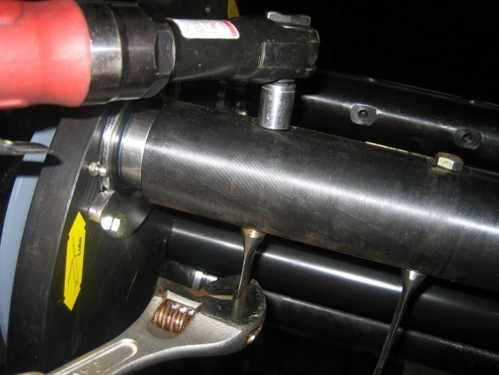
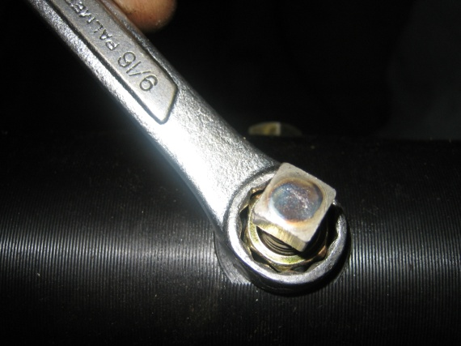
- Back off the square head set screw two complete turns. Set an adjustable wrench to the width of the tine. With the adjustable wrench hold the tine in the tine shaft in alignment and tighten the top bolt completely. An impact wrench is preferred. Note: This is the primary fastening mechanism for PlanetAir tines.

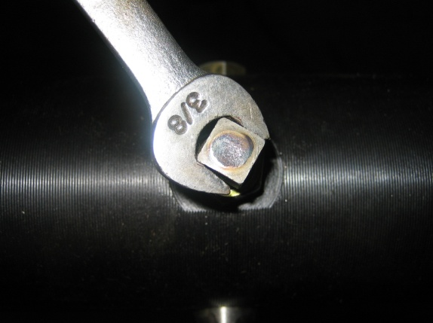

- Next, with a 3/8″ hand wrench tighten the square head set screw into the back of the tine. Note: Impact wrench will damage set screws and may damage threads in shaft.

- Last, with a 9/16″ hand-wrench tighten the jam nut on the set screw.

Spring Settings (relief system)
PlanetAir provides you with the ability to limit damage to the knife and the Aerator through a Gas Spring relief system at the rear of the Aerator.

Moving the springs forward increases the pressure on the aerator and rear roller. Moving the springs back transfer pressure to the tires protecting the aerator.

HINT: The key to using PlanetAir technology in fairways is to set a depth, head pressure and ground speed that allows the Aerator to operate effortlessly. Multiple passes and frequency will get the job done.

Place Aerator in the Maintenance position

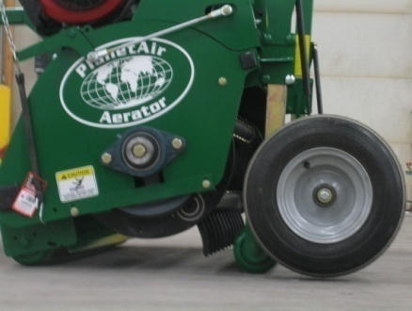
- Lower Aerator. Warning Flag Down.
- Check that Wheel Stop is in the Roller Down Position
- Loosen 8 Jack Clamp bolts
- Raise Rotor until tires leave the floor. With tire off the floor Gas Springs can be moved.
- Picture of recommended setting for greens.

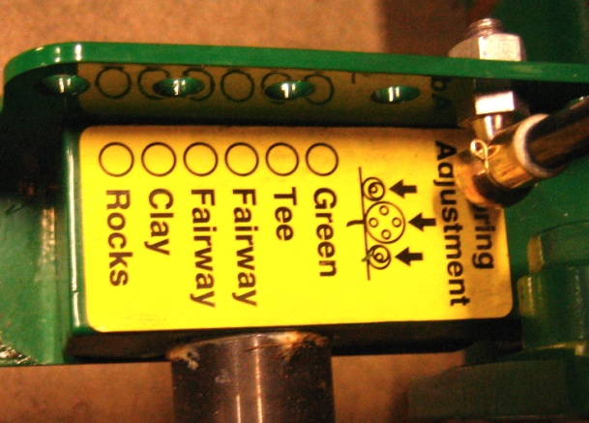

Roller Up / Roller Down Setting
The rear roller can be set up off the turf. Roller setting is made by positioning the Wheel Stop in the Roller Up or Roller Down hole. This is easily accomplished by raising the Aerator, sliding a block under the rear roller and lowering the Aerator. Rotor height always needs to be reset after this procedure.

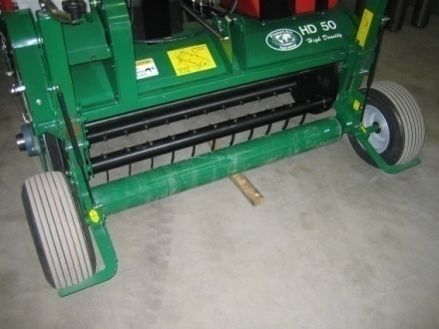
- Raise the Aerator
- Slide a block under the Rear Roller
- Lower the Aerator to the floor.
- Wheel Stop is placed in the Roller Up or Roller Down position. Both sides must be set the same.
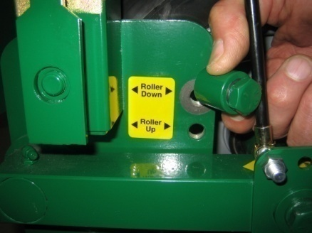

Rotor Height Adjustment
PlanetAir provides two Wheel Jacks at the rear of the Aerator to raise and lower the Rotor Head. Scales are provided to set Jacks evenly. Jacks are held in position with Jack Clamps. Eight bolts are loosened to change the settings and tightened when the adjustment is complete.

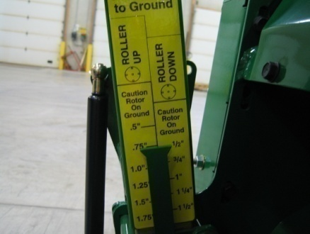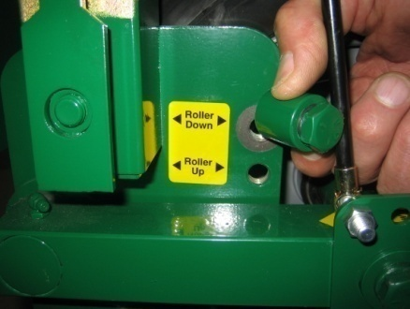
The Rotor Height scale is split into 2 scales.
- Roller Down: when set in the Roller Down position the Roller Down Scale is used.
- Roller Up: when set in the Roller Up position the Roller Up Scale is used.

The Rotor Height scale guides you on how close the rotor is to the ground and balances side to side settings.
- Lowering the Rotor while increasing depth, risks damage of the turf and the Aerator as the Rotor may contact the ground.
- Raising the Rotor reduces stress on the Aerator, avoids rocks and may also improve hole quality.

- Loosen 8 bolts holding Wheel Jack Clamps.
- Lower right and left jack lower than the final setting
- Raise each side equally to desired setting. Holding the gauge against the scale while cranking the Jack up provides for easier and more accurate reading.
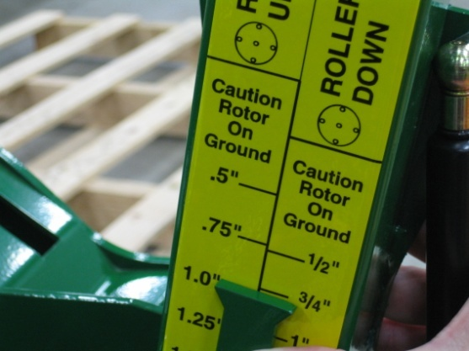

HINT: ¾″ clearance is a good choice for safe operation on normally undulating fine turf. Remember, the shop floor is hard, rollers and tires sink into soft ground and turf mat. Adjust accordingly
HINT: The key to using PlanetAir technology in fairways is to set a depth, head pressure and ground speed that allows the Aerator to operate effortlessly. Multiple passes and frequency will get the job done.

Timing Arm, Timing Spring, Timing Rubber Bumper Replacement

Place Aerator in the Maintenance position

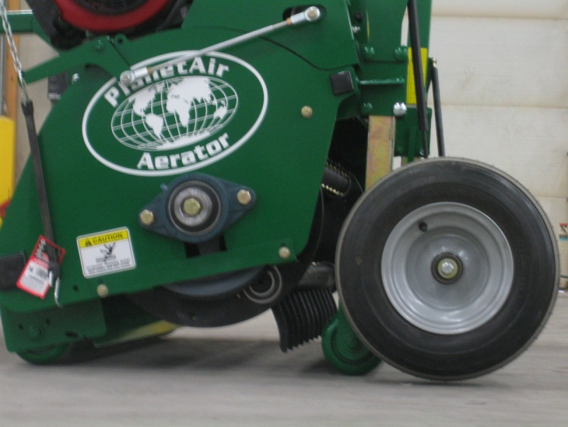

- Lower Aerator. Warning Flag Down.
- Check that Wheel Stop is in the Roller Down Position
- Loosen 8 Jack Clamp bolts
- Raise Rotor until tires leave the floor
- Pull off the Drive Belt Tensioner with a 12” rubber strap.

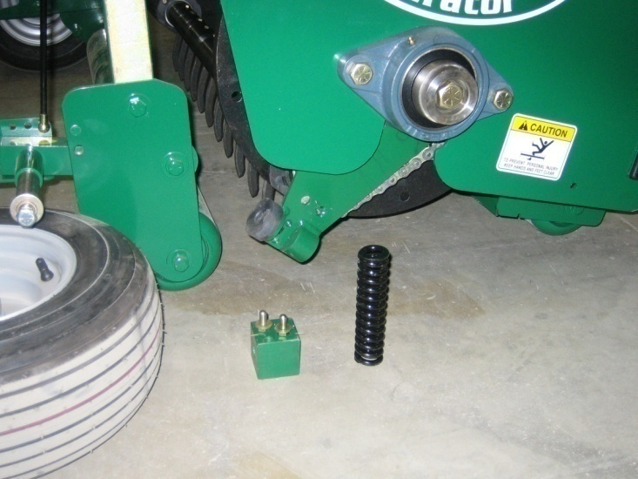
- Remove Right wheel
- Remove Timing Spring Block (Part# 560.206) and Timing Spring (Part #560.177-02) Inspect and replace if necessary.
- Timing Arm (Part# 560.221) will swing down for bolt removal and Timing Arm replacement
- Timing Arm will swing down for Timing Rubber Bumper (Part# 560.236) inspection and replacement

Hint: Timing Arm can be accessed and replaced with Rotor in the Aerator. There are 2 Timing Bumpers. One Bumper is fastened to the Timing Arm; the other Bumper is in the Housing. They should be replaced as a pair.

Hint: All fasteners require LocTite.

Timing Chain Replacement

PlanetAir uses two X-Ring Timing Chains (Maintenance-free).
- The Timing Chains hold the Tine Shaft in a specific relationship to the ground.
- Rotor must be fixed with a 5 ½″ pin through Rotor Disc and Timing Arm
- Opposing Tine Shaft must be fixed with Belt Retainer/ Timing Fixture

Hint: When a chain breaks related parts must be inspected.
- Tine Shaft Bearings (Part#560.03-04)
- Rotor Double Sprocket Bearings
- Timing Arm (Part#560.221)
- Timing Arm Spring (Part# 560.177-02)
- Timing Arm Rubber Bumpers (Pair) (Part#560.236)
- Reduction Belt (Part# 560.06-09) and Drive Belt (Part#560.06-08).

Place Aerator in the Maintenance position
- Lower Aerator. Warning Flag Down.
- Check that Wheel Stop is in the Roller Down Position
- Loosen 8 Jack Clamp bolts
- Raise Rotor until tires leave the floor.
- Remove Right Wheel
- Pull off the Drive Belt Tensioner with 12” rubber strap

Timing Chain Fixtures Required
- 5 ½″ long ½″ diameter bolt or pin
- Belt Guide/Timing Tool (Part#560.254)

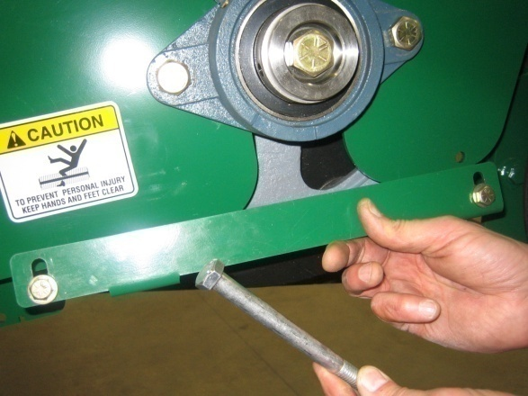

Timing Chain Fixtures Installation
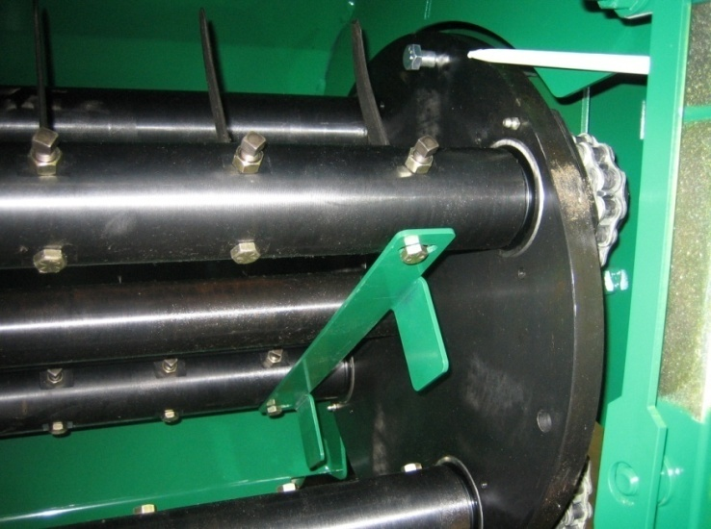

- Rotate the Rotor so one of the shafts is positioned as pictured.
- Slide the Timing Pin through the hole in the Rotor Disc and through the Timing Arm. This will lock the Rotor to the Timing Arm.
- Timing Tool (Part# 560.254) will hold opposing Tine Shafts with Knife pointing upwards.
- The Timing Chain (Part# 560.137-01) can now be installed on the opposing Tine Shaft.
- Remove Timing Pin and Timing Tool
- If necessary refixture the Rotor for second Timing Chain replacement
- After replacement Rotor should be rotated by hand a couple of complete revolutions. Free, quiet, smooth movement should exist.
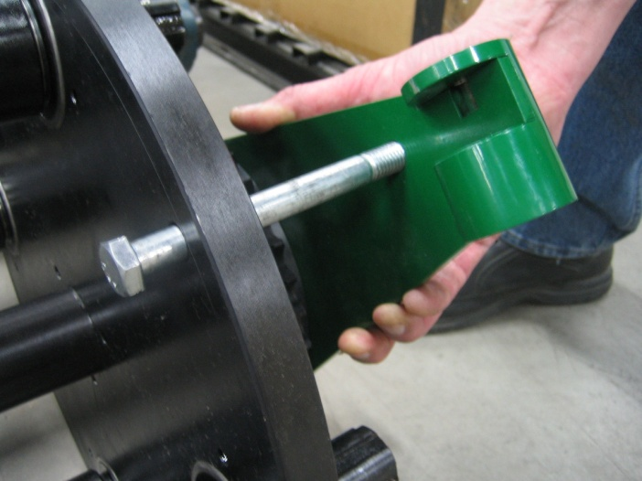
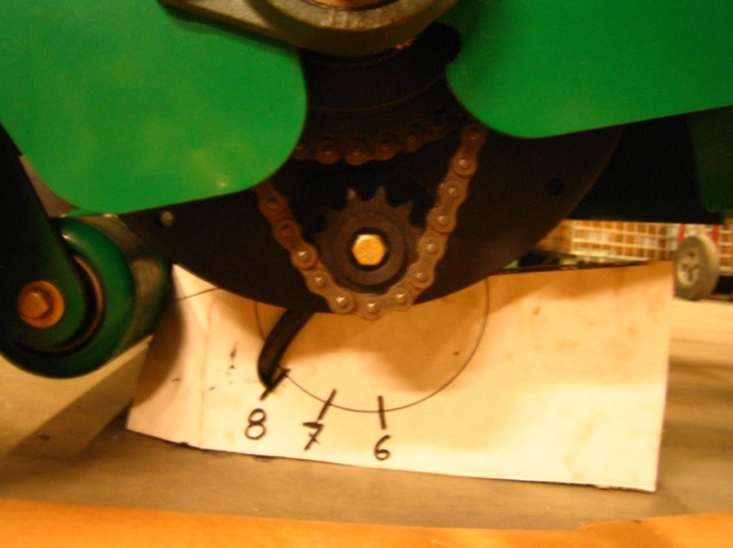
Rotate the rotor to make sure each shaft aligns to 8 o’clock position at the bottom of rotation
Picture taken with Rotor out of the Aerator for clarity

Tine Shaft Bearing Replacement

Place Aerator in the Maintenance position
- Lower Aerator. Warning Flag Down.
- Check that Wheel Stop is in the Roller Down Position
- Loosen 8 Jack Clamp bolts
- Raise Rotor until tires leave the floor.
- Remove Right Wheel
- Remove Timing Chain

Hint: Knife or Tine Shaft does NOT have to be removed for Tine Shaft Bearing replacement.

Hint: Timing Chain should be replaced after bearing failure. (Part#560.137-01) The Rotor may have to be rotated a number of times to access the connector link. OEM chain does not have a connector link.

Right Bearing Replacement

- Remove the Sprocket
- Remove the Bearing Retainer
- Replace Right Tine Shaft Bearing (Part# 560.03-04)
- Reassemble following Timing Chain Replacement procedure.

Left Bearing Replacement

- Remove right side Tine Shaft Bearing Retainer
- Slide Tine Shaft 2″ to the right
Hint: One Knife may need to be removed on the right side.
- Remove left Tine Shaft Bearing Retainer
- Replace left Bearing (Part# 560.03-04)
- Reassemble following Timing Chain Replacement procedure

Rotor Removal

For replacement of Rotor Double Sprocket, Rotor Pulley
- Lower Aerator completely. Warning Flag must be down.
- Loosen 8 Jack Clamp bolts
- Lower Jacks evenly until both Rotor Discs contact the ground.

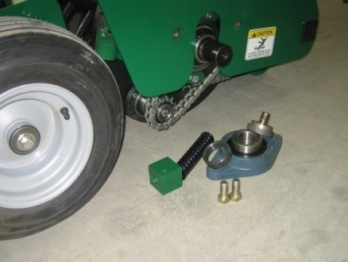
Right Side of Aerator
- Remove Wheel
- Remove Timing Spring Block
- Remove Center Shaft Retainer
- Remove Rotor Mounting Bearing

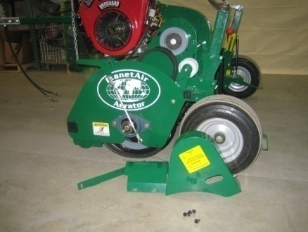
Left Side of Aerator
- Remove Wheel
- Remove Clutch Rod
- Remove Jack Shaft Guard
- Remove Small Belt Guard
- Remove Belt Retainer/Timing Tool
- Remove Center Shaft Retainer
- Remove Rotor Mounting Bearing

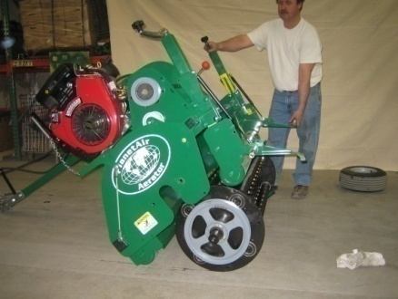
WARNING: Warning Flag must be down. Hitch Pole must be installed. Hitch Pole will serve as a support leg.

- With two people using the Wheel Axle and Jack as handles tilt the Aerator Housing up and over the Rotor. Roll the Housing forward. Place the Aerator Housing on the floor in front of the Rotor.

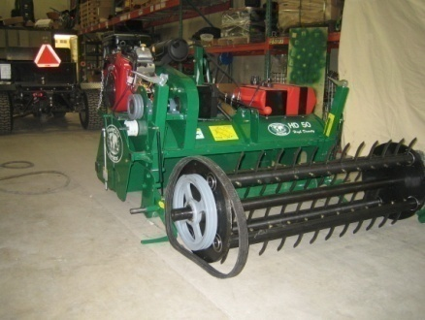
- Inspect Belt and replace if worn.
- Inspect Pulley and replace if worn.
- Inspect Double Sprocket and Bearings. Replace if worn. Chains must be removed to replace Double Sprocket. (See Timing Chain Replacement)
- Reverse Procedures for Assembly.

REMINDER: Use LocTite on all rotor related fasteners.

Belt Replacement

PlanetAir utilizes two belts – Reduction Belt coming off the engine and a Drive Belt off the left side of the rotor.

Reduction Belt (Part#560.06-09) is replaced by removing large belt guard on the inside of the Aerator. Change belt and reinstall guard.

Drive Belt Replacement – Quick method (Part#560-06-08)

- Remove Left Rotor Mounting Bearing
- Back off the bolts on the Right Rotor Mounting Bearing
- Slide the Rotor to the right side of the machine by prying between Left End Plate and the Pulley.
- Slide the Belt up between the End Plate and Pulley.

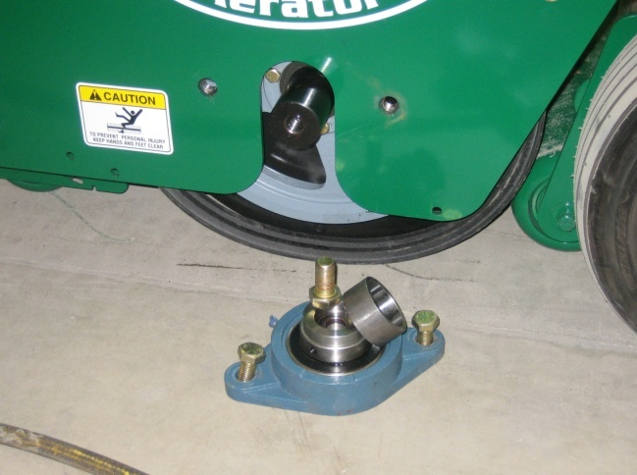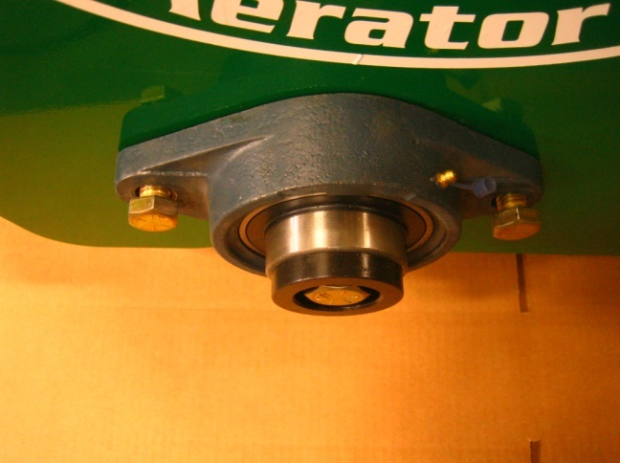

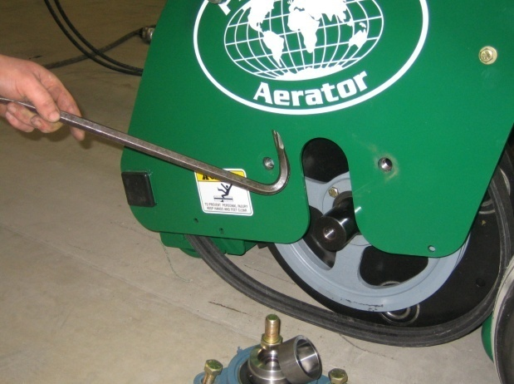

Wheel Jack Service and Lubrication
Place Aerator in the Maintenance Up position.
- Lower Aerator. Warning Flag Down.
- Check that Wheel Stop is in the Roller Down Position
- Loosen 8 Jack Clamp bolts
- Raise Rotor until tires leave the floor.

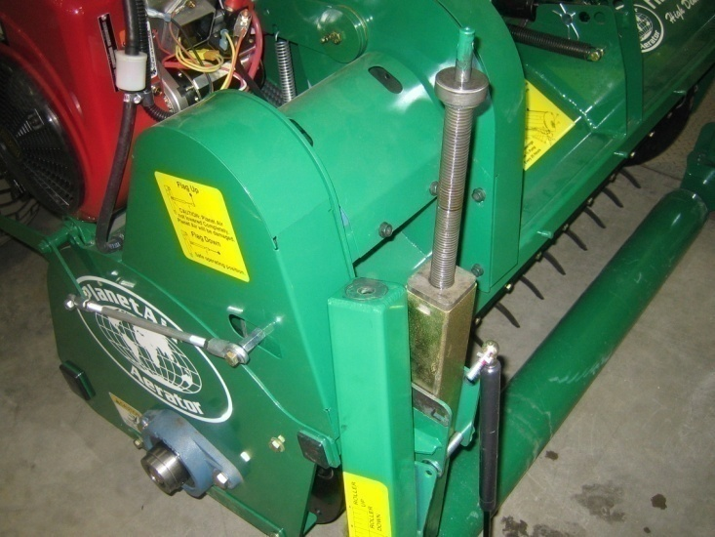

- Remove the Spring
- Tighten 2 lower bolts on Jack Clamp
- Remove 2 upper bolts on Jack Clamp
- Remove Jack Handle
- Remove Top of Jack
- Inspect Bearing and lubricate threads
- Oil inside of Upper Jack

Lubrication

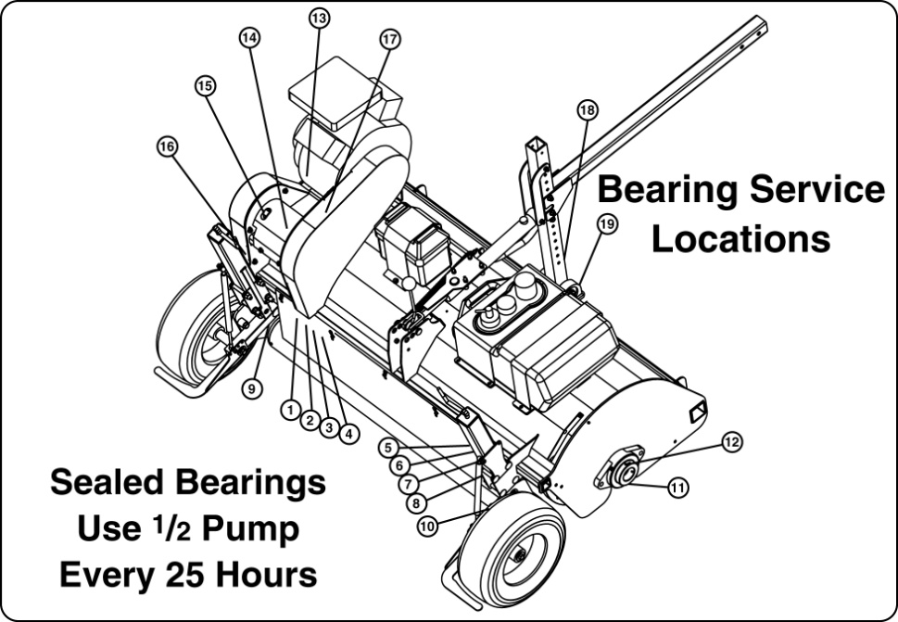

Location | Description | Frequency | Amount
1-8 | Tine Shaft Bearing  Part # 560.03-04 | Every 25 hours | ½ Pump
9-10 | Wheel, Arm, Pivot  Part # 560.238 | Daily
11 | Rotor, Double Sprocket  Part # 560.36 | Every 25 hours | 2 Pumps
12-13 | Rotor, Mounting Bearing  Part # 560.03-02 | Every 25 hours | ½ Pump
14-15 | Engine, Jack Shaft Bearing  Part # 560.03-05 | Every 25 hours | ½ Pump
16-17 | Belt, Tensioner Pivot  Part # 560.237 | Daily
18-19 | Hitch, Pivot Bearings  Part # 560.03-10 | Every 25 hours | ½ Pump

Troubleshooting

Problem Solutions
Tire is wobbling or rubbing on frame | Inspect for loose Axle Pivot  Inspect for bent Wheel or worn Wheel Bearing  Tire pressure too high. Set at 20 psi.  Missing Wheel Stop
Aerator is tufting, tearing or jumping on fine turf | Check Rotor Height Setting  Inspect Belt Tensioner Spring  Inspect for worn Drive Belt  Inspect condition of Timing Chain, Arm, Bumper and Spring.
Aerator makes clicking noise when working hard | Knife not installed correctly.  Tine Shaft Inspect condition of Timing Chain, Timing Arm, Timing Bumper and Timing Spring
Rear Roller is banging during transport | Inspect Tire pressure, Wheel Bearings and Wheel Arm Pivot  Inspect for missing Wheel Stop  Inspect Hitch Installation. Hitch should run downhill 2” to Aerator  Hint: moving Hitch Pole lower or raising ball height increases roller transport height.
Aerator won’t Pull Core | Review Knife Selection Guide and Aerator Setup  Ground too hard  Set head pressure to High  Worn Coring Knife  Thatch too deep for PlanetAir Coring Knife  Inspect for core buildup on Roller

Problem | Solutions
Roller marks | Review Rotor Height Adjustment procedures  Make sure height is set evenly for left & right Wheel Jack  Inspect for bent or loose Wheel Jack or Wheel parts
Roller Core Buildup | Review Coring Knife Setup

